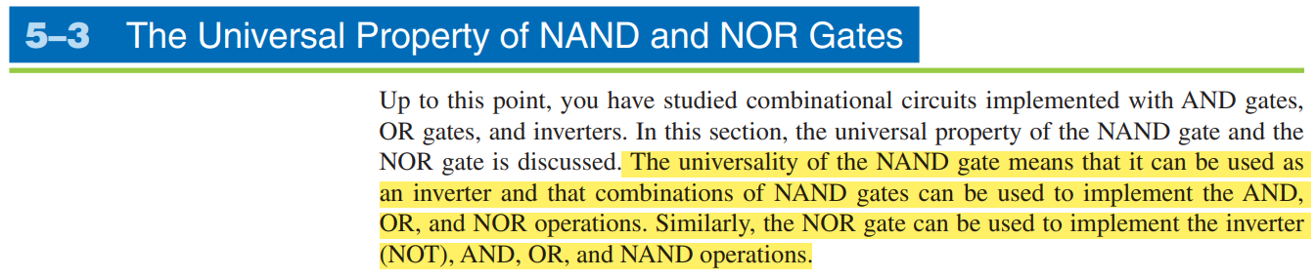

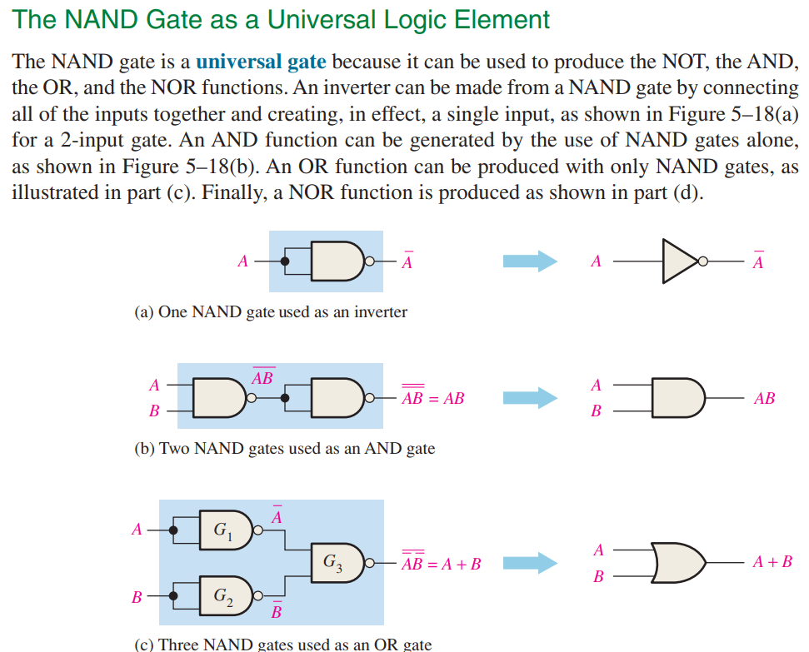

**If we want to make any gate, first look at the original gate and its equation, now we know what we want in the output of our NAND only circuit.**



